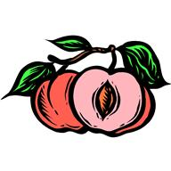
James and the Giant Peach
Vocabulary Words List 2
- immediately: without delay; instant
- mammoth: very big; huge
- swelling: to expand as a result of pressure
- miraculous: able to work miracles
- hammock: a bed of canvas or rope, swung from ropes at both ends
- chaos: extreme confusion or disorder
- vertically: upright; straight up and down
- peculiar: odd; strange
- mast: a vertical pole used to support a sail on a ship

