Explorers Unit Study Guide
For #’s 1-6 list all of the explorers that we have learned about in this unit.

1. john cabot 4. Henry Hudson
2. Jacques cartier 5. Juan Ponce De Leon
3. Christopher Columbus 6. Vasco Nunez de Balboa

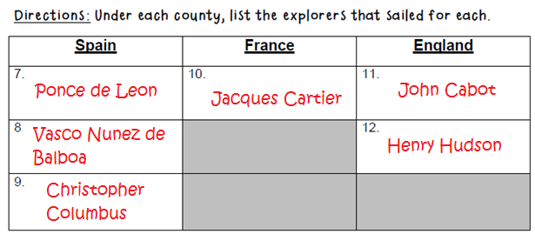
13.First to see the Pacific Ocean from Panama? __________VDB____________

14.Sponsored by the King and Queen of Spain in 1492? ___________Christopher Columbus____________

15. This explorer helped France get rich with the fur trade__________Jacques Cartier_____________

16.His crew mutinied (or rebelled) ________Henry Hudson_________

17. This explorer was never found after his crew left him and his son in a small boat in
the middle of the Arctic ________Henry Hudson_______

18. Juan Ponce De Leon was in search of _____the Fountain of Youth_____________

19. The Hudson Bay and the Hudson River were named after _____Henry Hudson____

20. This explorer named the St. Lawrence River ________Jacques Cartier_________

21. This explorer was the first person to explore and discover the “New World” _______Christopher Columbus_____

True or False?
22. The Northwest Passage was discovered by Vasco Nunez de Balboa. ___F____

23. Henry Hudson sailed for England. ___T______

24. John Cabot was in search of the Northwest Passage. ____T_____

25. The Fountain of Youth was found by Jacques Cartier. ___F______

Directions: Answer the essay question with complete sentences. Use details, and be sure to answer every part of the question.

26.What were some of the challenges that early explorers faced? Name at least two challenges and explain why those challenges made exploring difficult.
______________________________________________________________________Unchartered waters, starvation, weather, disease, Native Americans etc._______________________

27.What were two reasons people wanted to explore?
______________________________________________________________________fame, to be rich, gold, spices, trading, conqueror new land,/build empires, adventure______________________________________

Directions: Compare and contrast two explorers that we studied. What did they have in common and how are they different? List at least 2 items in each of the sections. Answers will vary.

