Explorers Unit Study Guide
For #’s 1-6 list all of the explorers that we have learned about in this unit.

1. 4.
2. 5.
3. 6.

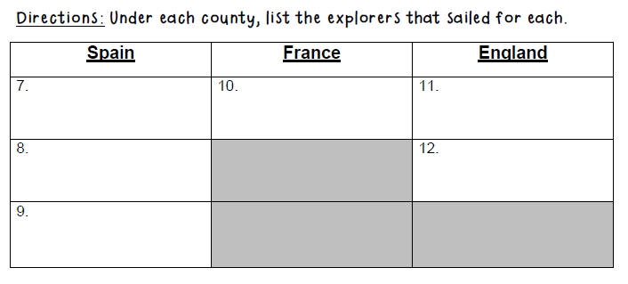
13.First to see the Pacific Ocean from Panama? _____________________________

14.Sponsored by the King and Queen of Spain in 1492? _______________________

15. This explorer helped France get rich with the fur trade_______________________

16.His crew mutinied (or rebelled) _______________________

17. This explorer was never found after his crew left him and his son in a small boat in
the middle of the Arctic _______________________

18. Juan Ponce De Leon was in search of ___________________________________

19. The Hudson Bay and the Hudson River were named after ___________________

20. This explorer named the St. Lawrence River ______________________________

21. This explorer was the first person to explore and discover the “New World” _____________________________

True or False?
22. The Northwest Passage was discovered by Vasco Nunez de Balboa. ___________

23. Henry Hudson sailed for England. ___________

24. John Cabot was in search of the Northwest Passage. ___________

25. The Fountain of Youth was found by Jacques Cartier. ___________

Directions: Answer the essay question with complete sentences. Use details, and be sure to answer every part of the question.

26.What were some of the challenges that early explorers faced? Name at least two challenges and explain why those challenges made exploring difficult.
____________________________________________________________________________________________________________________________________________________________________________________________________________________________________________________________________________________
27.What were two reasons people wanted to explore?
____________________________________________________________________________________________________________________________________________________________________________________________________________________________________________________________________________________

Directions: Compare and contrast two explorers that we studied. What did they have in common and how are they different? List at least 2 items in each of the sections.

