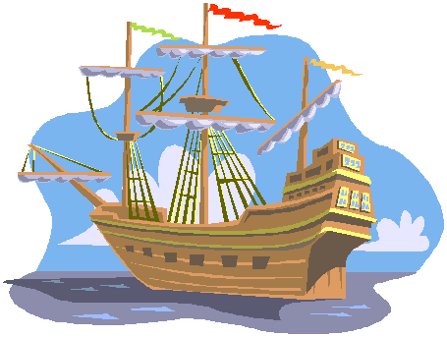
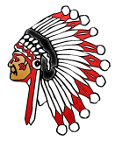
America’s
Beginning
Vocabulary

- Pueblos- Native American village made up of stone or adobe houses with flat roofs.
- Legend- an old story that has been retold and is believed to be true
- Totem pole- a cedar pole carved, and decorated to tell about a tribe’s legends, and stories
- Artifacts- discovered remains of past human life and activities
- Harpoon- a sharp spear used especially in hunting large fish or whales
- Moccasins- soft leather shoe; originally worn by native Americans
- Expedition - a journey to achieve a goal
- The Northwest Passage – A route early European explorers were in search of that was a quicker water route to Asia.
- Circumnavigate – To sail completely around something
- Conquistador – Spanish word for Conqueror

America’s
Beginning
Vocabulary

- Pueblos- Native American village made up of stone or adobe houses with flat roofs.
- Legend- an old story that has been retold and is believed to be true
- Totem pole- a cedar pole carved, and decorated to tell about a tribe’s legends, and stories
- Artifacts- discovered remains of past human life and activities
- Harpoon- a sharp spear used especially in hunting large fish or whales
- Moccasins- soft leather shoe; originally worn by native Americans
- Expedition - a journey to achieve a goal
- The Northwest Passage – A route early European explorers were in search of that was a quicker water route to Asia.
- Circumnavigate – To sail completely around something
- Conquistador – Spanish word for Conqueror

